QUALITY ASSURANCE
Higher Education is very essential for active participation in the knowledge societies which in turn accelerate economic growth. Quality Education is a prerequisite to gain access to knowledge which guarantees economic development. This makes the condition of higher education in Pakistan a very critical issue. Recognizing this, the Higher Education Commission (HEC) is committed to quality assurance and enhancement of higher education in institutions. To achieve world class standards, quality assessment and continuous improvement are the necessary ingredients. This includes the accreditation of academic programs and quality assessment of the institutions. HEC has developed procedures and guidelines for quality assurance and its enhancement.
HEC has established the Quality Assurance Agency (QAA) with the objective of significant enhancement of quality in higher learnings and international compatibility. The major function of QAA is to integrate the concepts of quality in the higher learning systems and to develop practical guidelines and policies for uplifting the standard of education in Pakistan by establishing a viable Quality Assurance mechanism. One of the basic components of Quality Assurance Process is Self Assessment System for the academic programs.
The purpose of establishing Quality Enhancement Cell (QEC) at PIFD is to enhance the quality practices to excel in academics and research nationally and internationally. The prime mandate of QEC is to plan, apprise, coordinate and follow up the activities of conducting Self Assessment (SA) of the Teaching Departments in terms of their Degree Programs on the basis of Criteria, Standards and Survey Forms incorporated in the Self Assessment Manual (SAM) to determine the weaknesses and to address the same to achieve the following objectives and it is a continuous process:
- Improvement and maintenance of academic standards
- Enhancement of students’ learning
- Verify that the existing programs meet their objectives and institutional goals
- Provide feedback for quality assurance of academic programs

VISION: To be leading public sector higher education institution in the areas of fashion and design by taking best quality assurance measures to ensure highest quality of education compatible and competitive with the international standards.

MISSION: To deliver high quality teaching and learning with sustainable quality strategies in academics to meet the challenges of the rapidly changing world that consistently emphasize:
- Creativity and innovation;
- Industry relevance and employability;
- Enterprise and entrepreneurship;
- Professional excellence; and
- Socially responsible, ethical professional practice.
ORGANOGRAM
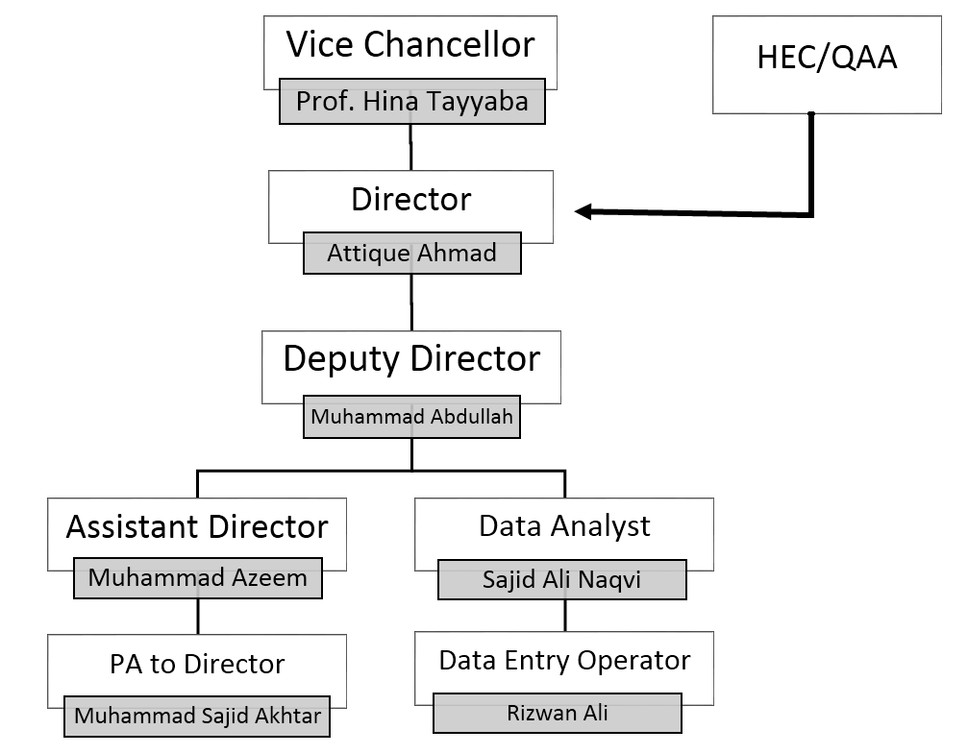
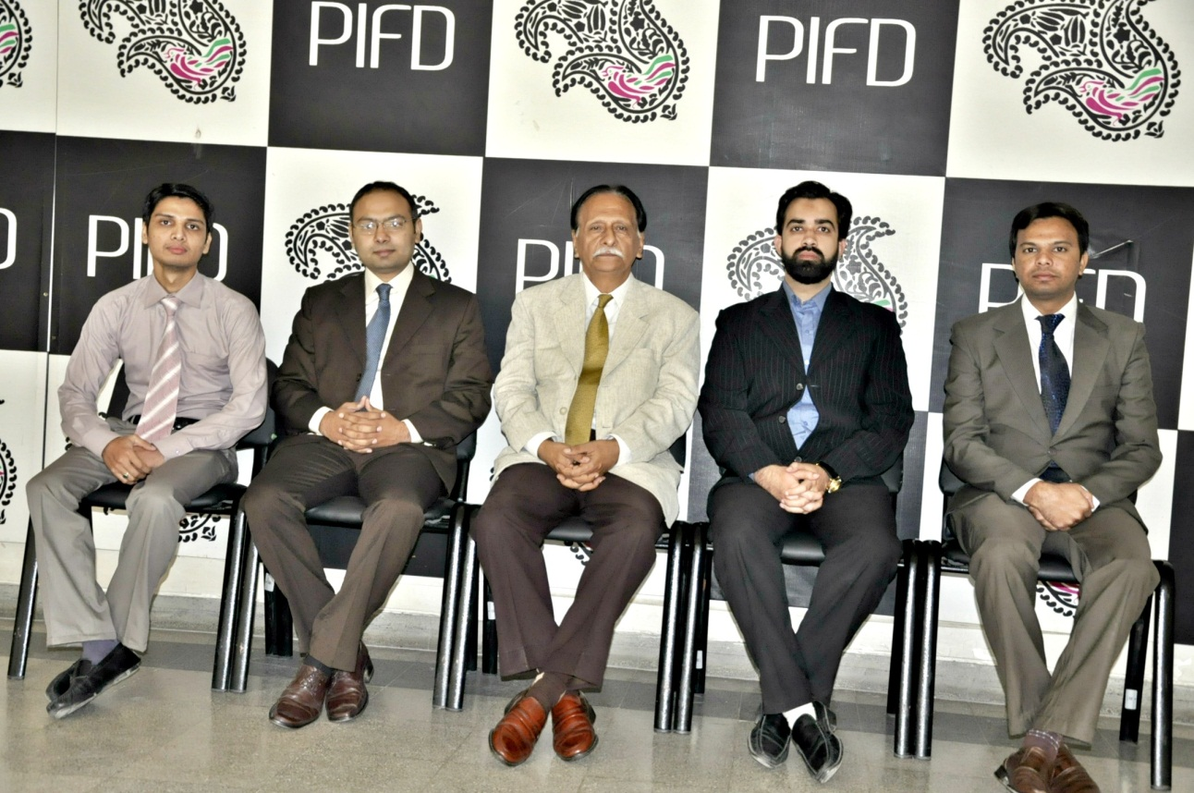
SELF ASSESSMENT PROCEDURE
QEC initiates SA through Course Coordinator/HOD one semester prior to the assessment
QEC forms PT in consultation with the department that will be responsible for preparing SAR
QEC reviews Documentation within one month
SAR
Complete
YES
NO
Vice Chancellor forms AT in consultation/recommendation with Registrar, Course Coordinator/HOD and QEC
QEC plans and fixes AT visit
AT conducts assessment and presents its findings to QEC, Course Coordinator/HoD, PT and dept. faculty
QEC submits an executive summary to the Vice Chancellor
Department prepares implementation plan summary
Follow up of the implementation plan by QEC

LEGEND
- QEC: Quality Enhancement Cell
- PT: Program Team
- SA: Self Assessment
- SAR: Self Assessment Report
- AT: Assessment Team

PROGRESS
During the period under report, QEC reviewed and finalized the Self Assessment Reports (SARs) submitted by the already constituted Program Teams (PTs) of the following departments:
- Department of Textile Design
- Department of Furniture Design and Manufacture
- Department of Leather Accessories and Footwear
QEC conducted awareness sessions with the already constituted Assessment Teams (ATs) of the said departments to create awareness regarding conduction of assessment/evaluation of the academic programs of the departments in view of SARs.
QEC arranged visits of ATs to the departments for assessment of the academic programs wherein Course Coordinators/Head of Departments, PTs, Faculty and QEC Staff were present. ATs submitted the Assessment Reports to QEC including status of addressing the criteria and its associated standards as under:

Sr.No. | Departments | Academic  Program | C r i t e r i a |  |  |  |  |  |  |  | Cumulative  Score | Status
 |  |  | C1 | C2 | C3 | C4 | C5 | C6 | C7 | C8
1. | Textile Design | B.Des. | 4.5 | 17.5 | 8.67 | 8.67 | 12.27 | 11.43 | 5.33 | 9 | 77.37 | Good to Excellent Performance in all areas
2. | Furniture Design and Manufacture | B.Des. | 4.00 | 15.5 | 6.67 | 8.00 | 11.45 | 9.71 | 4.67 | 4 | 64 | Good Performance for most areas/No poor performance in any areas
3. | Leather Accessories and Footwear | B.Des. | 4.83 | 17 | 8 | 9.33 | 14.45 | 13.71 | 3.33 | 5 | 75.67 | Good to Excellent Performance in all areas

KEY TO DETERMINE PROGRAM STATUS

 | Score Range | Status
 | 01-20 | Poor Performance in most of the areas
 | 21-40 | Fair Performance in most of the areas
 | 41-60 | Good performance for most areas/ no poor performance in any areas
 | 61-80 | Good to excellent performance in all areas
 | 81-100 | Excellent performance in all areas
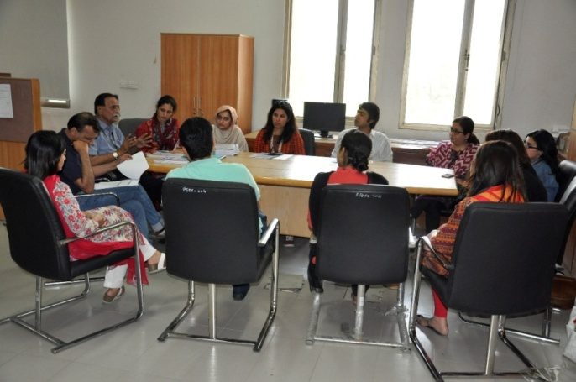  Assessment – Department of Textile Design |  |  | 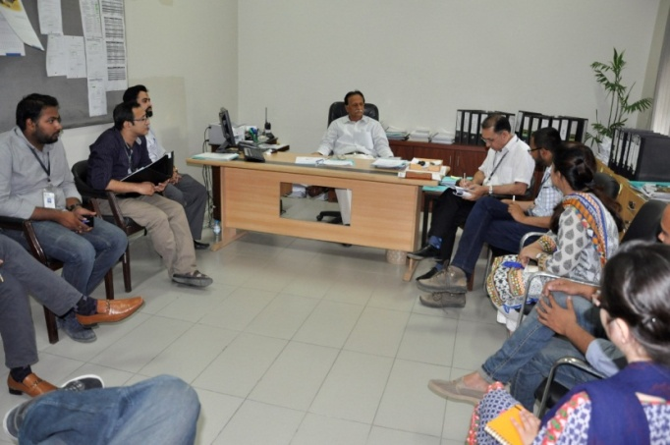  Assessment – Department of Furniture Design  and Manufacture
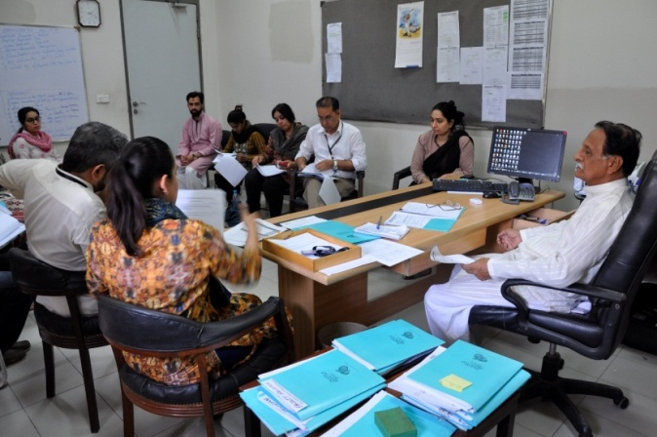
Assessment – Department of Leather Accessories and Footwear
In accordance with Self Assessment Procedure, QEC conducted the Exit Meetings of the Departments i.e. Textile Design, Furniture Design & Manufacture and Leather Accessories & Footwear Chaired by the Director QEC wherein Course Coordinators / Head of Departments, ATs, PTs, Faculty and QEC Staff participated. The Team Leaders of ATs presented their findings in detail regarding allocation of scores on all the eight (08) criteria and its thirty one (31) associated standards before finalization of the Assessment Report and also furnish recommendations.

After completion of SA process, QEC submitted the Executive and Assessment Results Implementation Plan Summaries of each assessed department to the Vice Chancellor for perusal / consideration. QEC also submitted Yearly Progress Report (YPR) for the period ending 10th July 2015 to QAA, HEC, Islamabad for Internal Quality Assurance (IQA) rating. The Score Card has been received from QAA, HEC, Islamabad wherein PIFD secured 80% score.

During the period under report, QEC also conducted survey of Faculty Evaluation of Foundation Year Studies and six departments by the students of Semester Spring 2015. The Data collected was analyzed by using SPSS software and developed a comprehensive report. Summaries of the Faculty Evaluation Reports have been delivered to all the Course Coordinators / Head of their respective departments. Letters depicting scores obtained on the basis of evaluation during the semester has also been delivered to faculty members for information regarding their performance under confidential cover with copies to the Registrar to place the same in their personal files.
The Graphical Representation of the Faculty Evaluation is as under:

Consolidated Faculty Evaluation Score of Departments (Spring 2015)
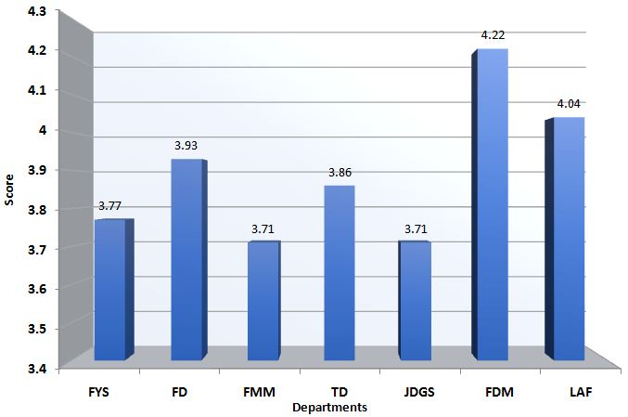

Segment-wise Average Faculty Evaluation Score of Departments (Spring 2015)
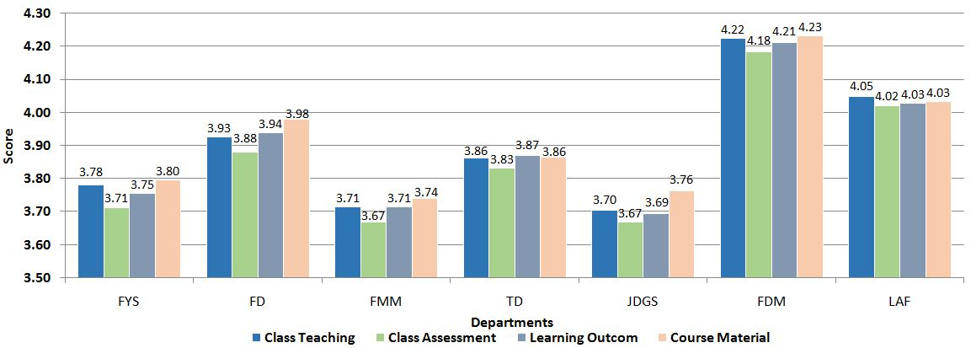

In order to prepare Self Assessment Reports (SARs) of the remaining three (03) departments i.e. Fashion Design, Fashion Marketing & Merchandizing and Jewellery Design & Gemological Sciences in terms of degree program during the semester Fall 2015 started on 24th August 2015, QEC re-constituted Program Teams (PTs) as under:

PROGRAM TEAMS
Sr.No | Name | Designation
Department of Fashion Design
1 | Ms. Faiza Khalid | Assistant Professor (Team Leader)
2 | Mr. Abdul Manan Khalid | Assistant Professor
3 | Ms. Fatima Jabeen Iqbal | Assistant Professor
Department of Fashion Marketing and Merchandising
1 | Ms. Khadija Hassan | Assistant Professor(Team Leader)
2 | Ms. Asma Khan | Lecturer
3 | Mr. Asaad Imtiaz | Lecturer
4 | Ms. Eesha Shahid | Lecturer
Department of Textile Design
1 | Mr. Allahdad | Assistant Professor (Team Leader)
2 | Ms. Maria Riaz | Lecturer
3 | Mr. Zohaib Azhar | Lecturer
4 | Ms. Maheen Ausaf | Lecturer
Department of Jewellery Design and Gemological Sciences
1 | Muhammad Umar | Assistant Professor (Team Leader)
2 | Ms. Amina Rizwan | Assistant Professor
3 | Ms. Qurat-ul-Ain Ali | Lecturer
Department of Furniture Design and Manufacture
1 | Mr.Talha Ahmed | Assistant Professor (Team Leader)
2 | Ms. Nayab Safdar | Lecturer
3 | Ms. Abeer Tahir | Lecturer
4 | Ms. Tatheer Zahra | Lecturer ( Foundation Year Studies)
Department of Leather Accessories and Footwear Design
1 | Mr. Rehan Javed | Lecturer (Team Leader)
2 | Mr. Zeeshan Naseem | Faculty Member / Consultant
3 | Ms. Nabiha Aftab | Lecturer
4 | Ms. Muniba Iftikhar | Lecturer

QEC conducted the awareness sessions with the Program Teams (PTs) of the departments to apprise them about Self Assessment Manual (SAM) through powerpoint presentation as per following plan particularly eight (08) criteria, its thirty one (31) associated standards and ten (10) Survey Forms in detail for preparation of Self Assessment Reports (SARs) of the Departments in terms of their academic programs:

- Overview; | vi. TORs of Program Teams;
- QEC Establishment; | vii. Self Assessment Criteria, Standards and Survey Forms
- Definitions; | viii. Concluding Remarks;
- QEC Functions; | ix. Conclusion; and
- Self Assessment Procedure; | x. Question/Comments.

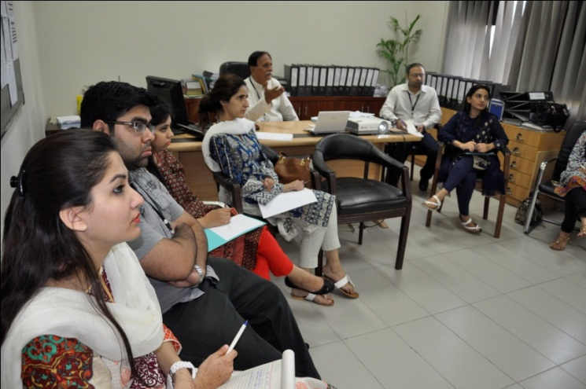 | 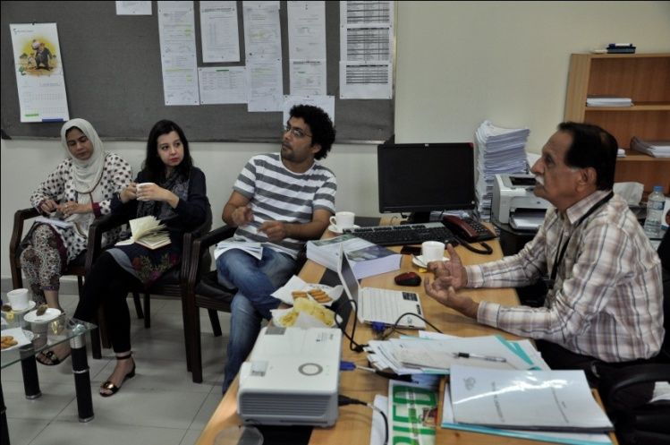
Awareness Sessions with Program Teams
To assess the SARs, QEC also re-constituted the Assessment Teams (ATs) in consultation and recommendations of the Registrar, Course Coordinators/Head of Departments and with the approval of the Vice Chancellor, as under:

ASSESSMENT TEAMS
Sr.No | Name | Designation
Department of Fashion Design
1 | Mr. JavedAkhtar Mir | Associate Professor, Leather Accessories and Footwear (Team Leader)
2 | Ms. Asmarah Ahmad | Assistant Professor, Foundation Year Studies
3 | Mr. Abdul Manan | Assistant Professor, Fashion Design (Subject Expert)
Department of Fashion Marketing and Merchandising
1 | Ms. Maida Hassan | Assistant Professor, Foundation Year Studies (Team Leader)
2 | Ms. Mariam Ali | Assistant Professor, Foundation Year Studies
3 | Ms. Asma Khan | Lecturer, Fashion Marketing and Merchandising (Subject Expert)
Department of Textile Design
1 | Ms. Fareeha Sardar | Assistant Professor, Leather Accessories and Footwear (Team Leader)
2 | Mr. Waqas Ahmad | Assistant Professor, Fashion Design
3 | Mr. Zohaib Azhar | Lecturer, Textile Design (Subject Expert)
Department of Jewellery Design and Gemological Sciences
1 | Mr. Muhammad Asim Naeem | Associate Professor, Fashion Design (Team Leader)
2 | Ms. Bushra Jamil | Assistant Professor, Textile Design
3 | Ms. Amina Rizwan | Assistant Professor, Jewellery Design and Gemological Sciences  (Subject Expert)
Department of Furniture Design and Manufacture
1 | Ms. Shawana Abid | Associate Professor, Fashion Design (Team Leader)
2 | Mr. Muhammad Kamran | Assistant Professor, Textile Design
3 | Ms. Abeer Tahir | Lecturer, Furniture Design and Manufacture (Subject Expert)
Department of Leather Accessories and Footwear
1 | Ms. Umber Zahid | Associate Professor, Textile Design (Team Leader)
2 | Mr. Qaiser Khan Shinwari | Assistant Professor, Furniture Design and Manufacture
3 | Ms. Nabiha Aftab | Lecturer, Leather Accessories and Footwear (Subject Expert)

Director QEC attended "Auditor Transition Training Course – ISO 9001:2015 QMS” at PIQC Institute of Quality, Lahore on November 18-19, 2015.

